https://stackoverflow.com/questions/30141209/how-to-use-javascript-export-keyword-in-browser-or-console

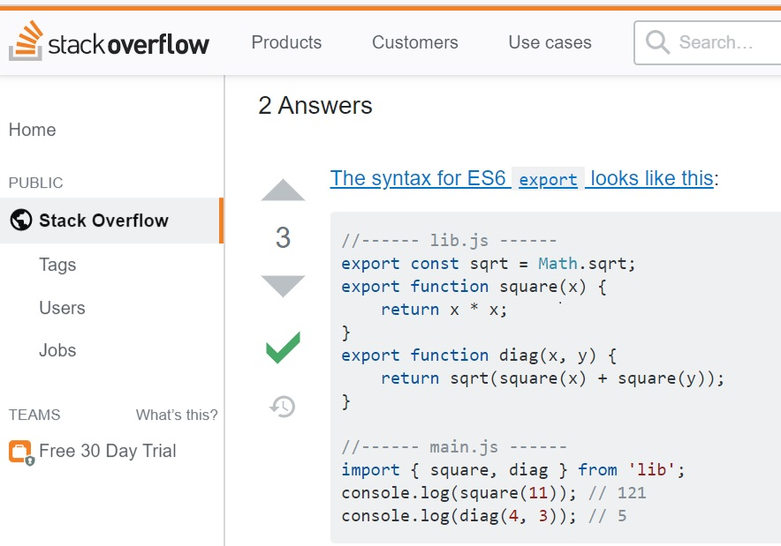
//------ lib.js ------
export const sqrt = Math.sqrt;
export function square(x) {
return x * x;
}
export function diag(x, y) {
return sqrt(square(x) + square(y));
}

//------ main.js ------
import { square, diag } from 'lib';
console.log(square(11)); // 121
console.log(diag(4, 3)); // 5



